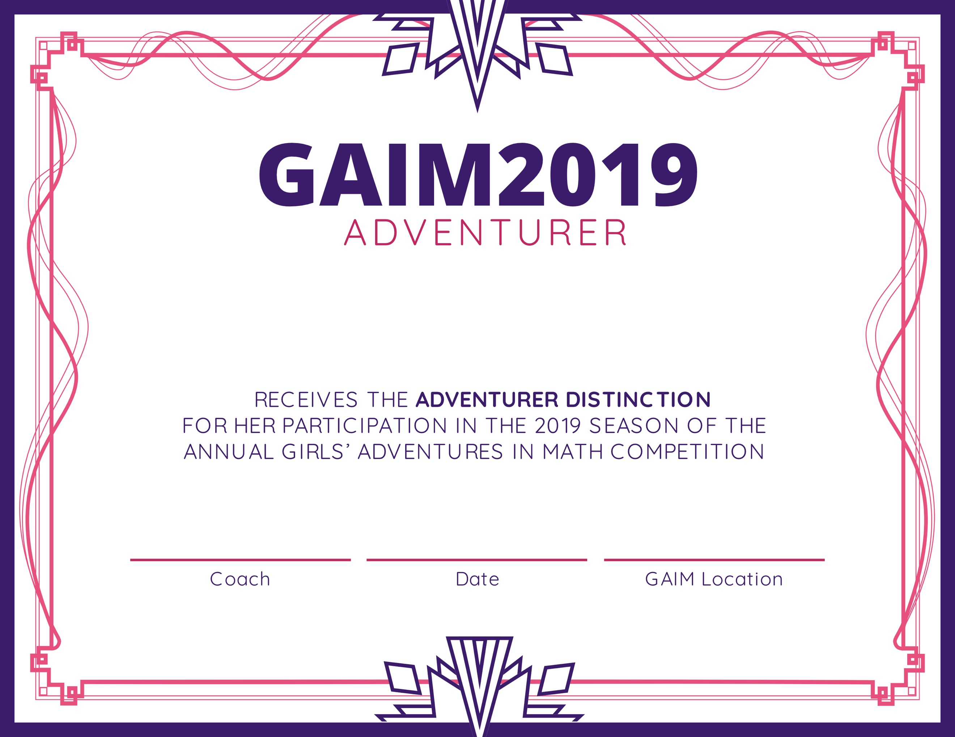

GAIM Host Site

16 May 2019

Coach Name Here

Student Name