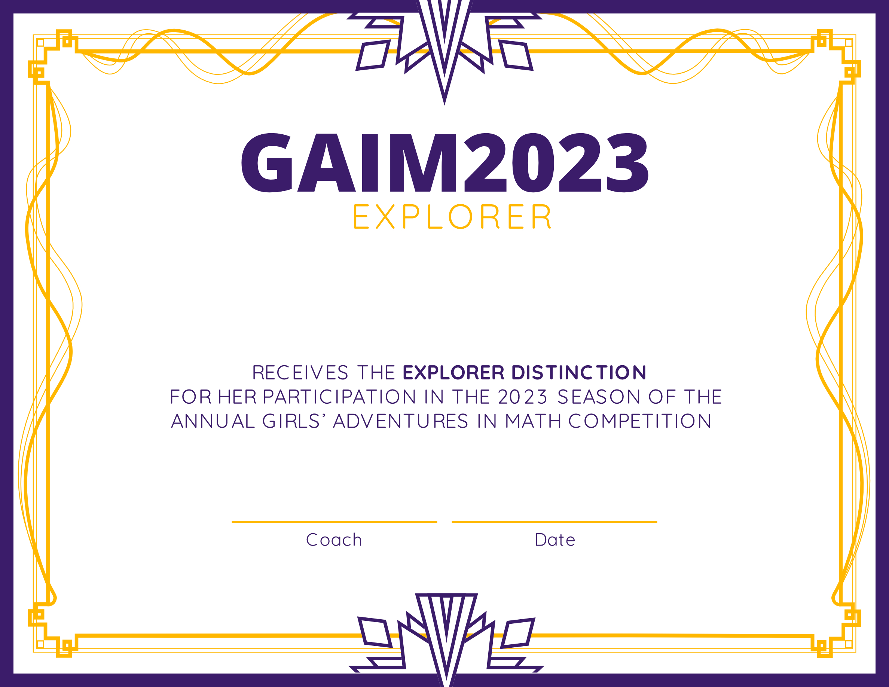

20 May 2023

Coach Name Here

Student Name