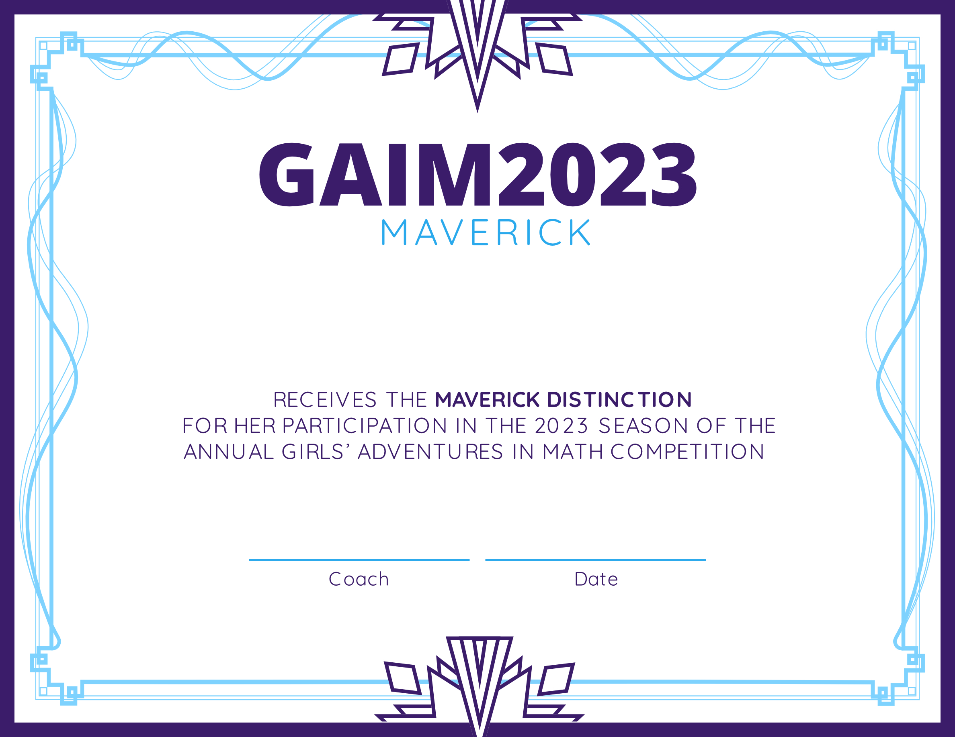

Coach Name Here

20 May 2023

Student Name